**Introduction**

Agenda:

1. What is Git
2. What is GitHub
3. Is Git related to GitHub
4. A simple workflow

1) Git - VCS - Version Control System

* To track changes in files/folders
* To collaborate with teams
* Free and open source

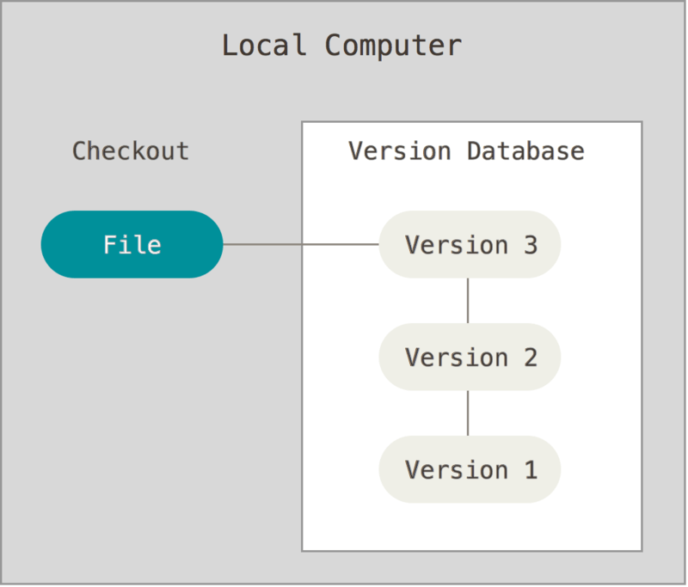 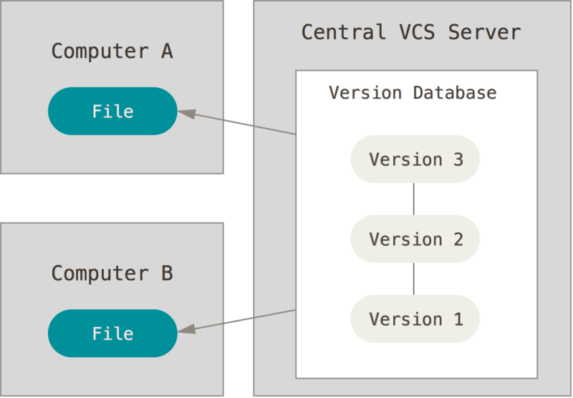

VCS - Centralised VCS & Distributed VCS

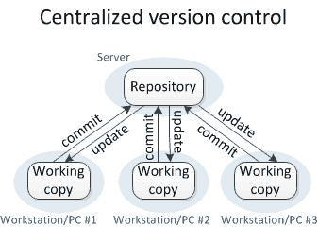 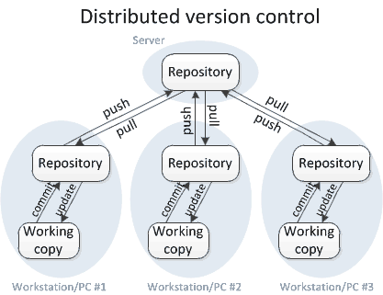

Git - Distributed VCS

2) GitHub

* Website to upload your repositories online
* Provides backup
* Provides visual interface to your repo
* Makes collaboration easier

3) Git != GitHub

4) Simple Git workflow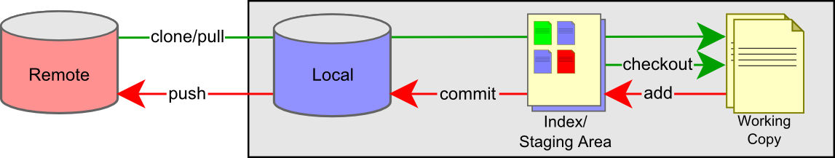

**Install Git on Windows**

Agenda:

1. How to install git on windows
2. Adding projects to git for tracking
3. Git commands
4. Pushing projects to remote repository

1) How to install git on windows

-> Check whether git is already installed or not

-> If it is installed it will show installed version otherwise it will show command not found

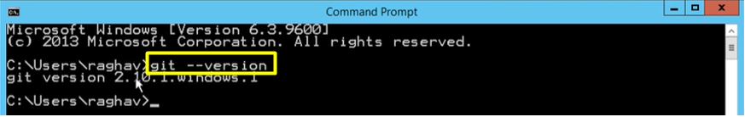

-> Download & install git

[https://git-scm.com](https://git-scm.com/) -> 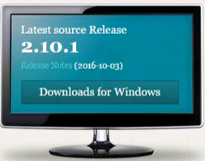 ->  -> Run exe file -> Next -> Next

-> Check Use git from Git Bash only -> Next -> Next -> Install   
-> Check installation -> Open new instance of command promt and check

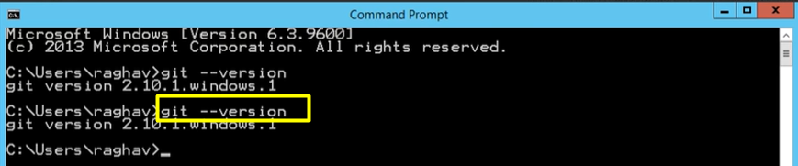

2) Projects to Git for tracking

Using command prompt:

-> Create new folder on desktop: My project -> Open folder -> In folder explorer bar type cmd and enter

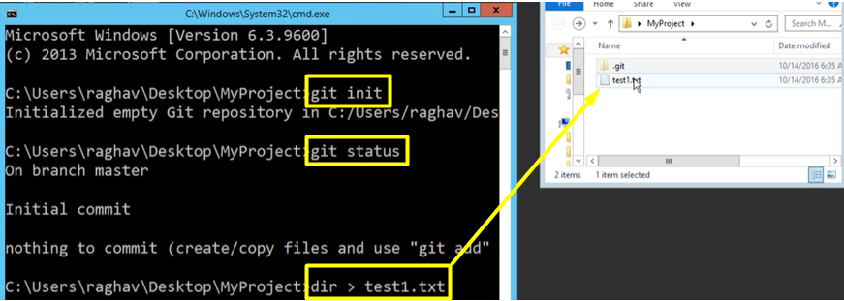

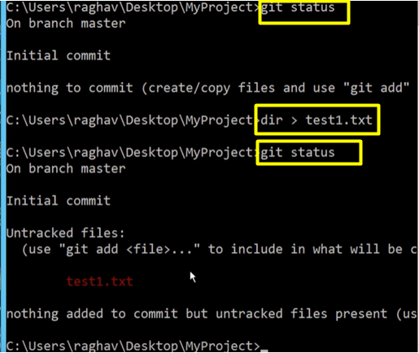

Using Gir Bash:

Open folder -> Right click - Git Bash here

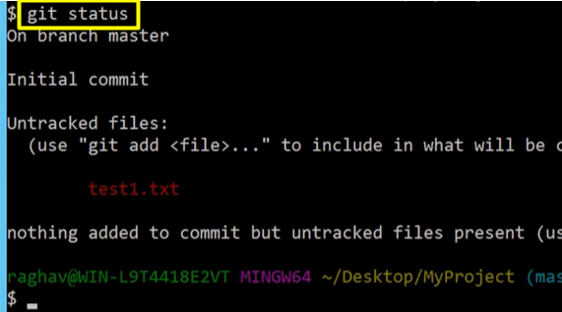

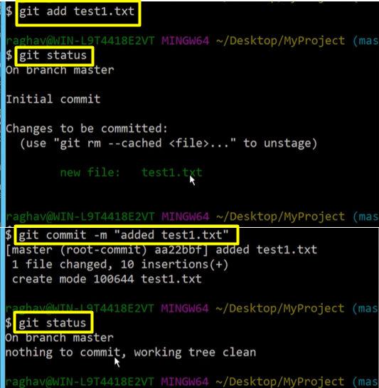

-> Modify te test1.txt and add index.html

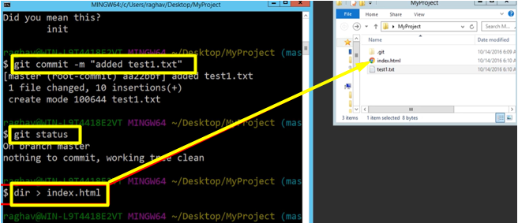

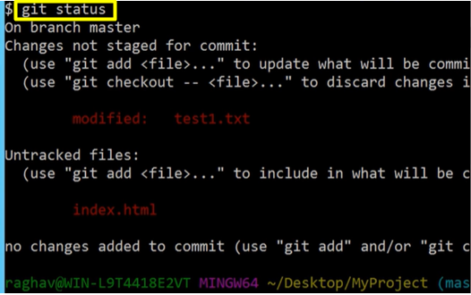

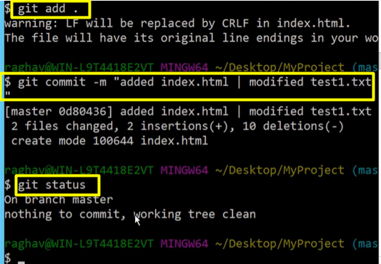

3) Git commands

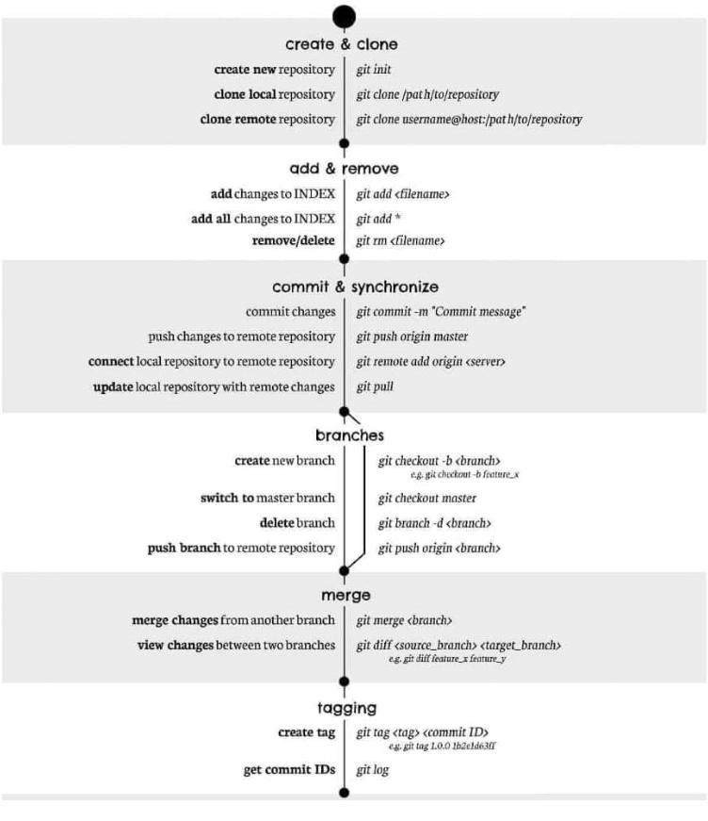

4) Pushing projects to remote repository

Go to: [https://github.com](https://github.com/) -> Create account -> + -> New repository

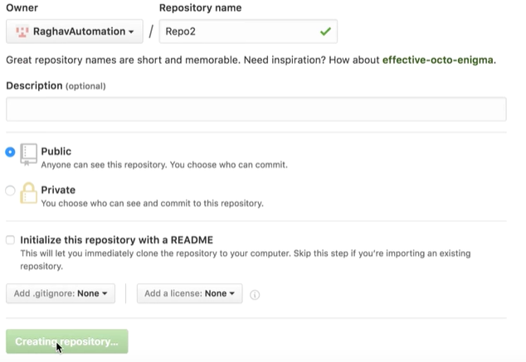

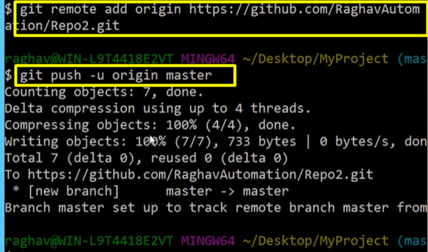

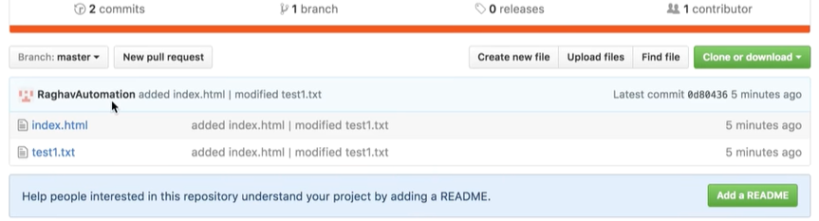

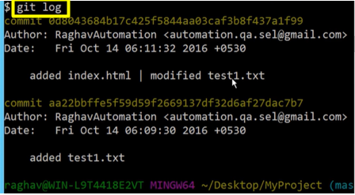

Commands:

* git config --global user.email "name@email.com"
* git config --global user.name "username"
* git init
* git status
* git add .
* git commit -m “message”
* git remote add origin https://github.com/RaghavAutomation/R...
* git push -u origin master
* git log
* git –help

**Branching & Merging**

Agenda:

1. What are branches
2. How to craete branch
3. How to checkout branch
4. How to merge brach to master
5. How to delete branch (local and remote)

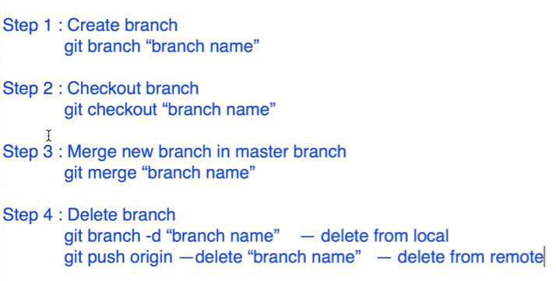

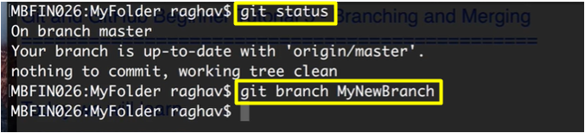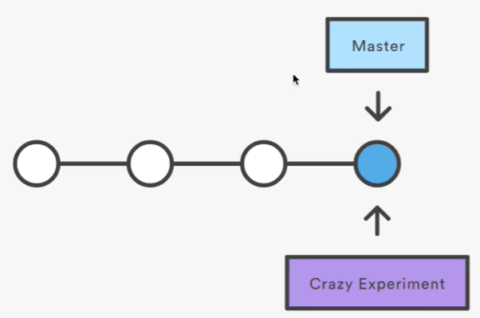



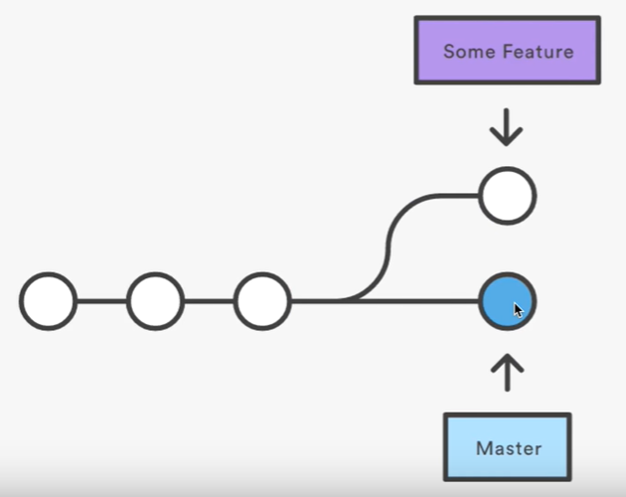

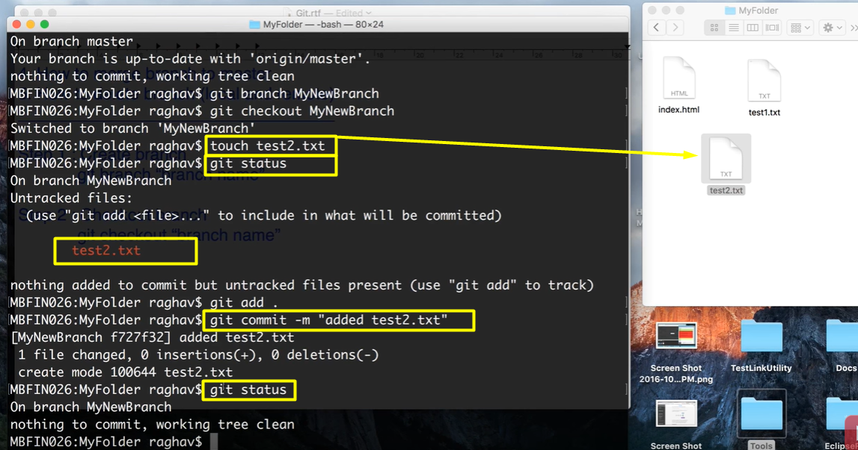

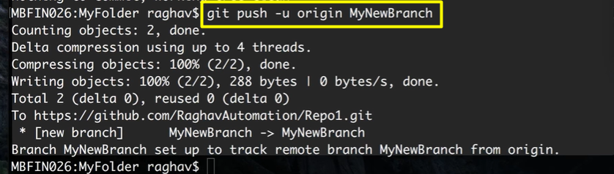

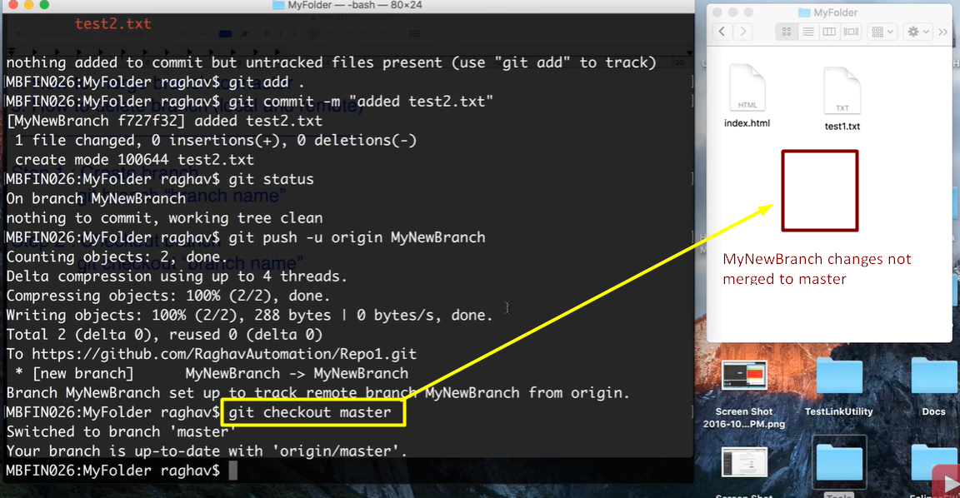

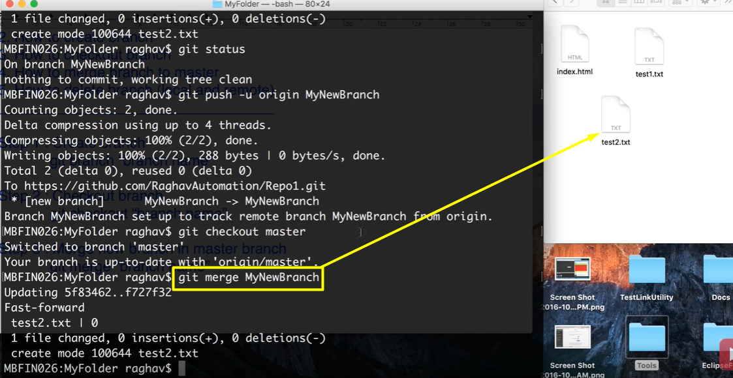

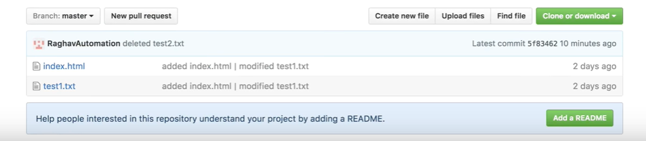

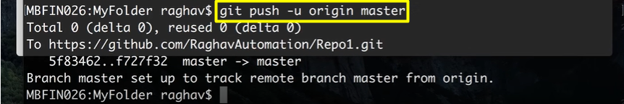

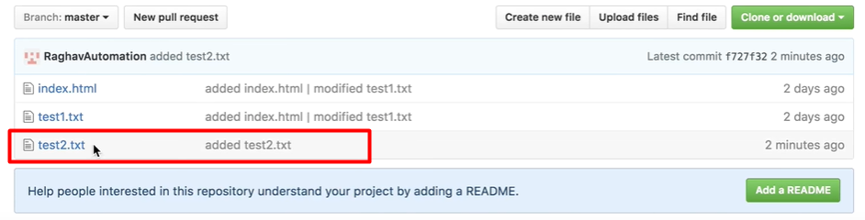

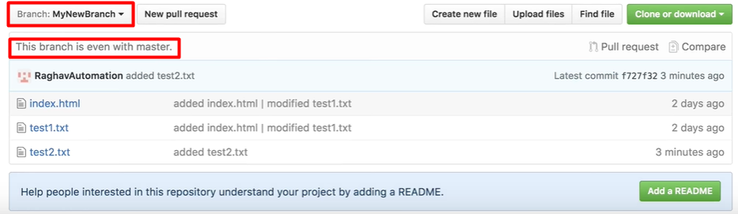

-> Once we merge the changes in MyNewBranch to master, we may have or no longer need that branch(we can delete MyNewBranch)

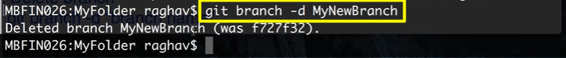

-> It will deletes only local MyNewBranch but it remains in remote repo(GitHub)

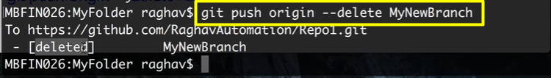

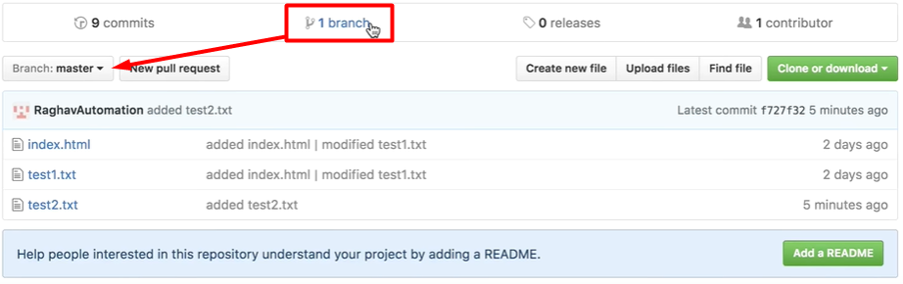

**Send Email from GitHub**

GitHub -> Repository -> Settings -> Add Service -> Available Services: email -> Email

-> Address: automation.qa.se@gmail.com -> Check Send from author -> Add service

=> For every change to the repository, Added email will get the notifications

**Git Tags - what, why, when and how**

Agenda:

1. What are tags/releases
2. Why should I create Tags
3. When to create Tags
4. How to craete tags in Git

create | show | publish | delete

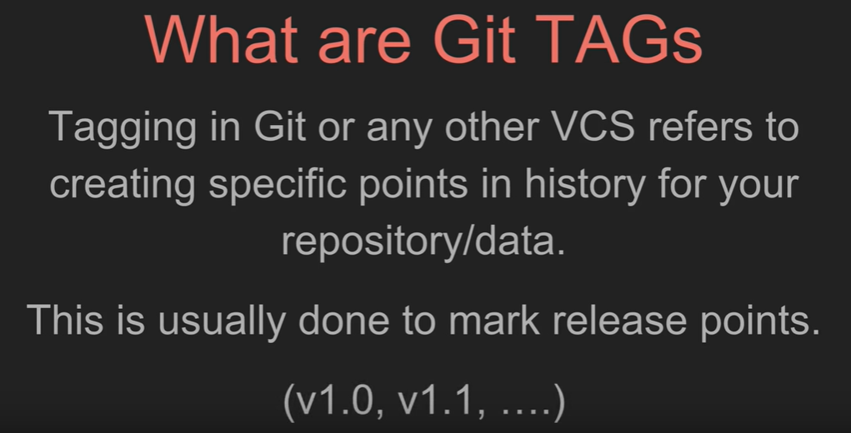

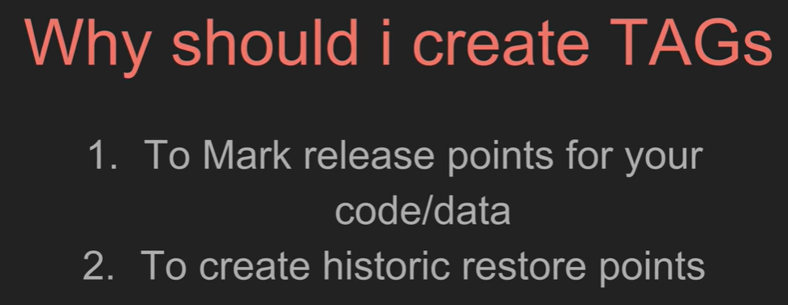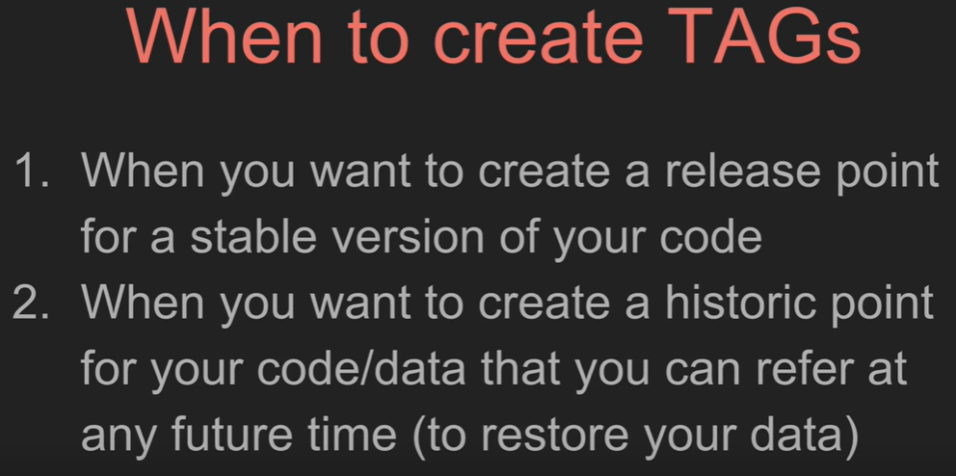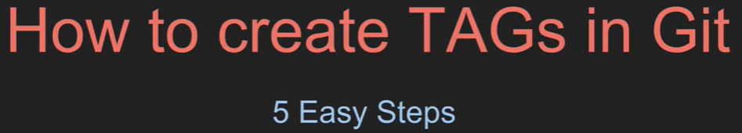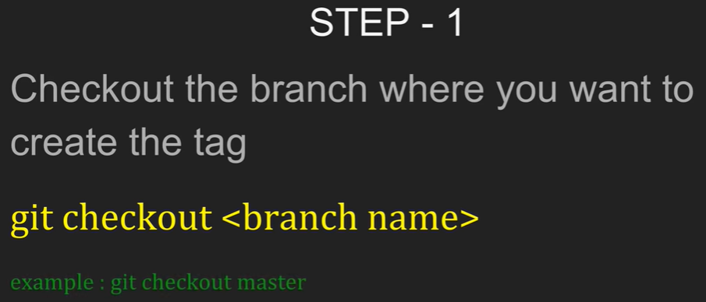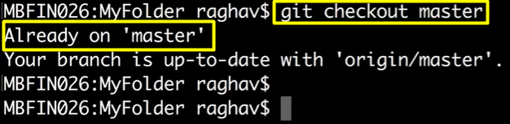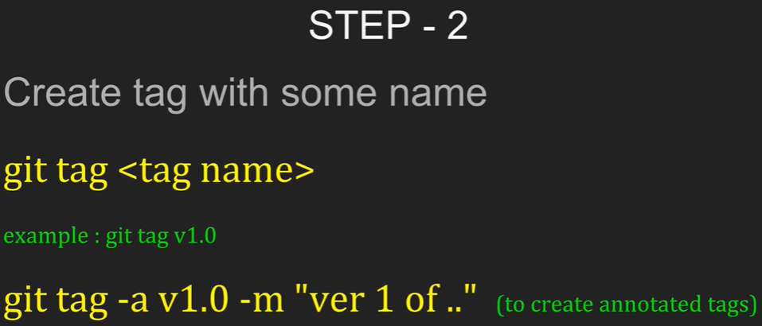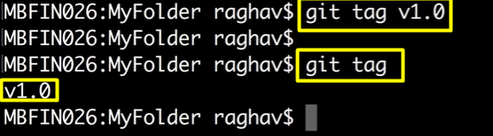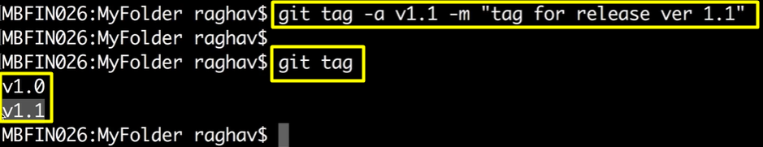

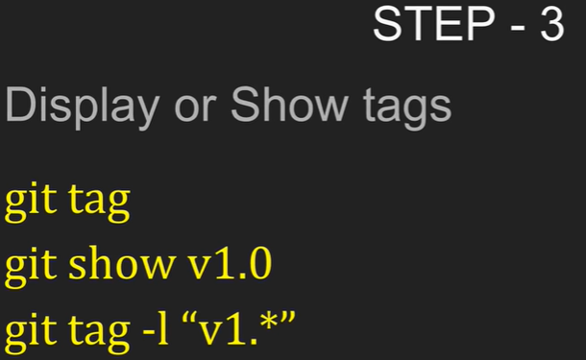

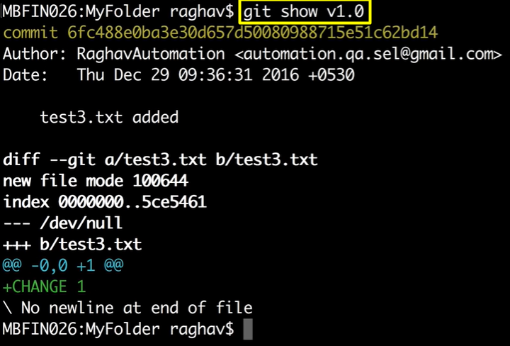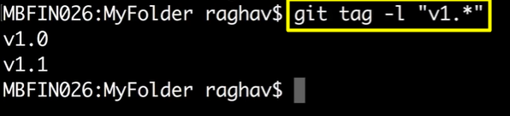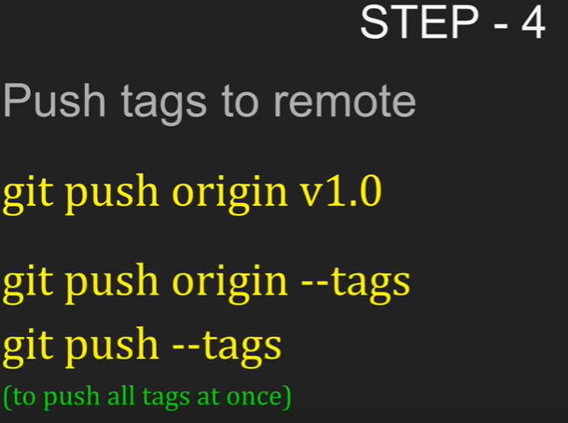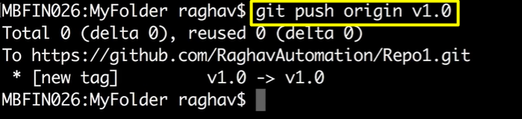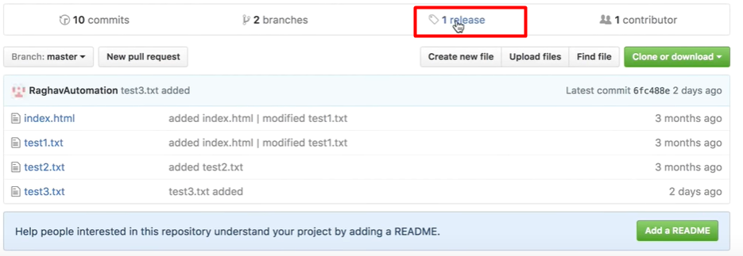

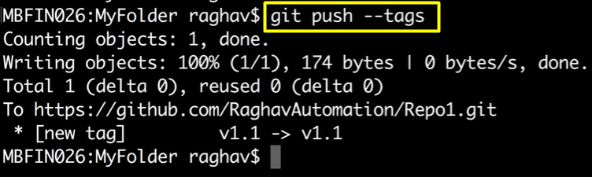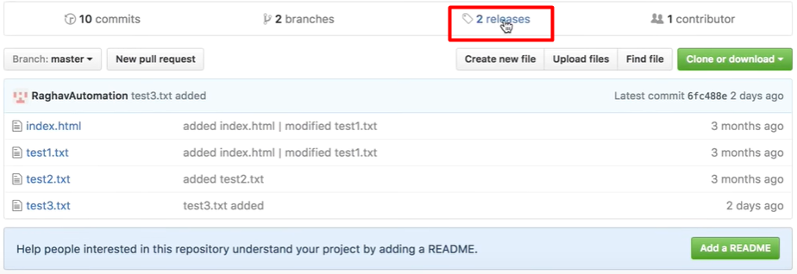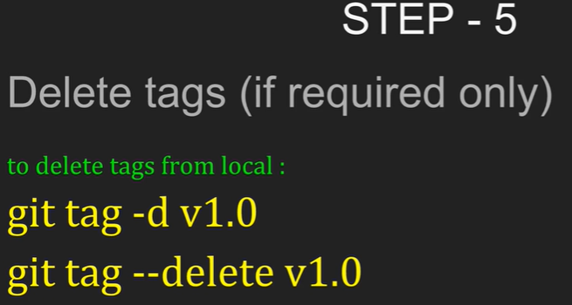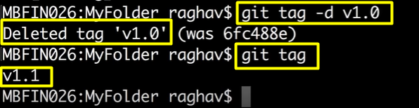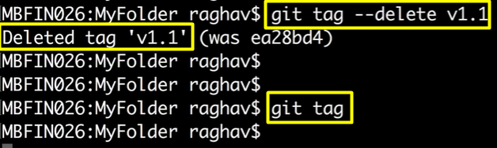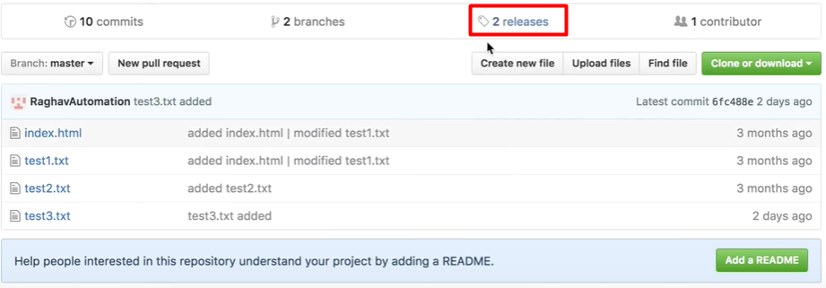

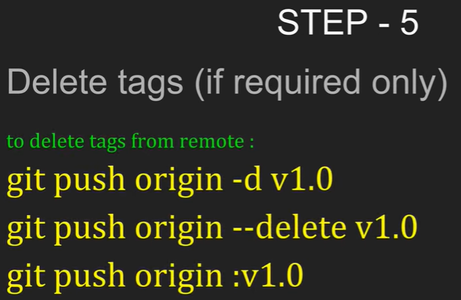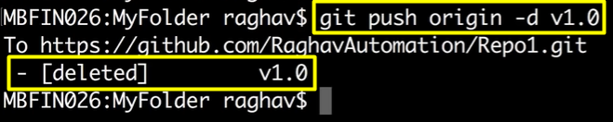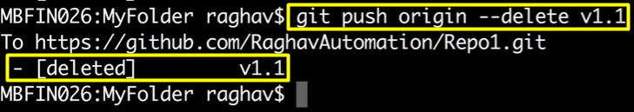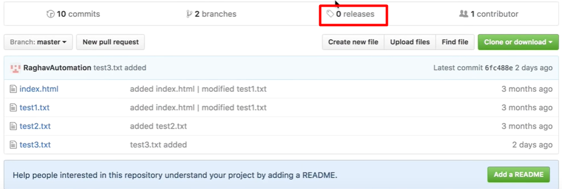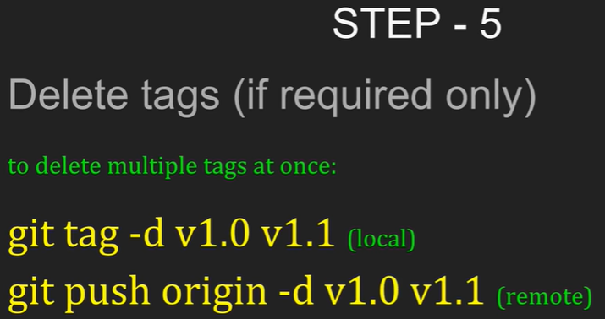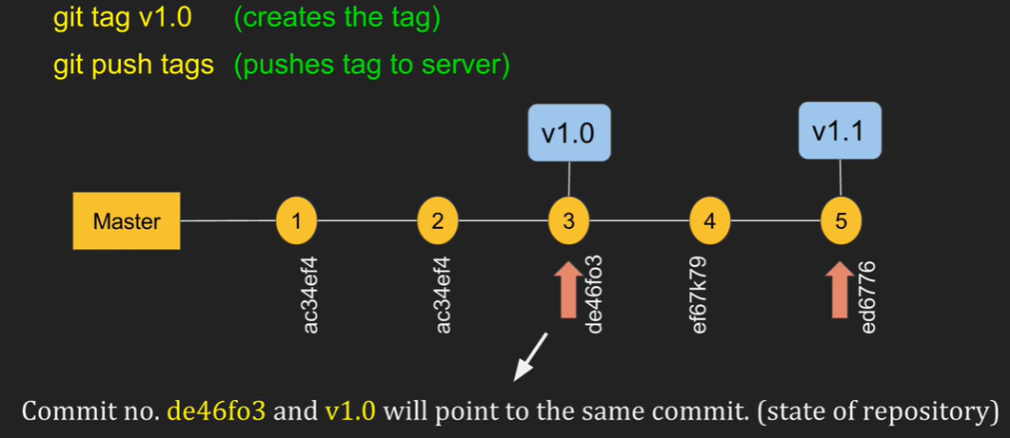

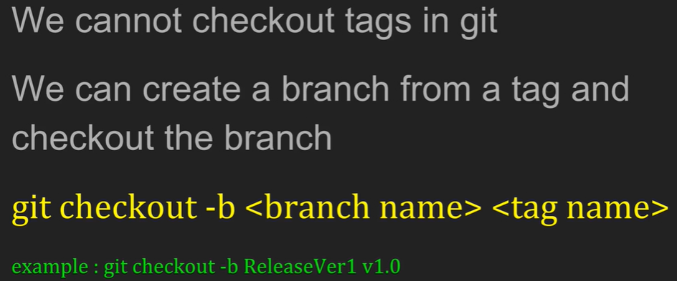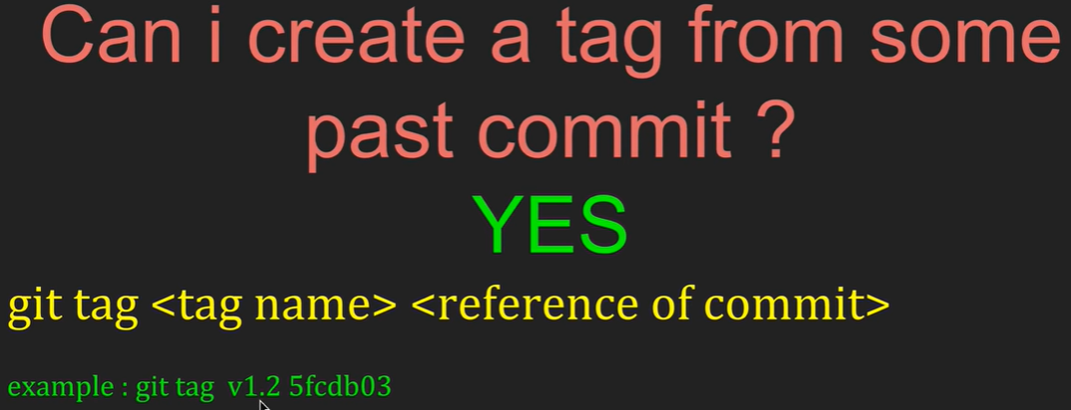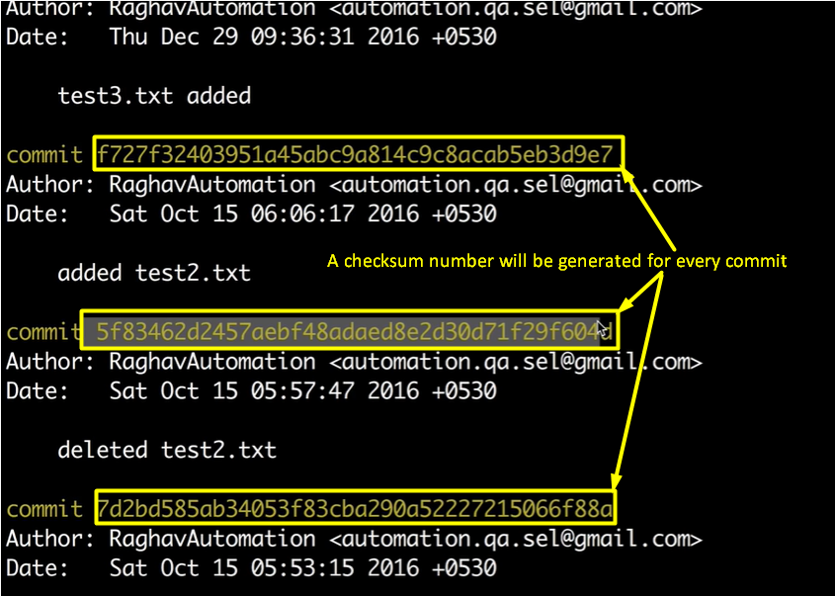

-> To create tag from some past commit we don’t need to use complete checksum number, we can use part of checksum number.

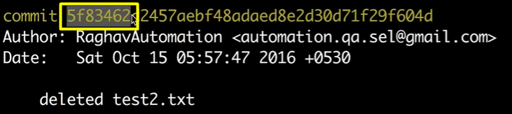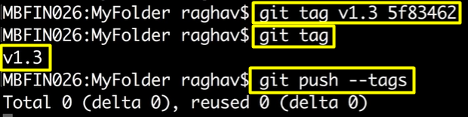

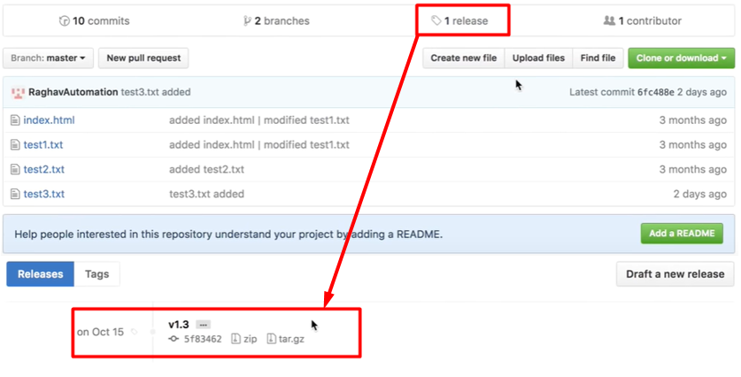

-> This is how we go back & taging in your repository

**Git Merge vs Git Rebase**

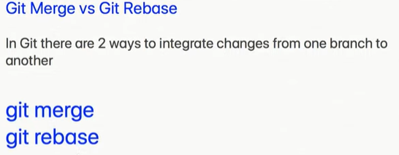

**Git Merge:**

Create a folder: gitdemo1 -> Open Git bash in the filder

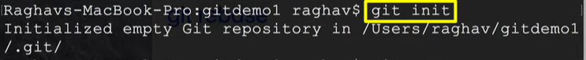

-> To create file inside folder from command propt in windows: dir > m1.txt

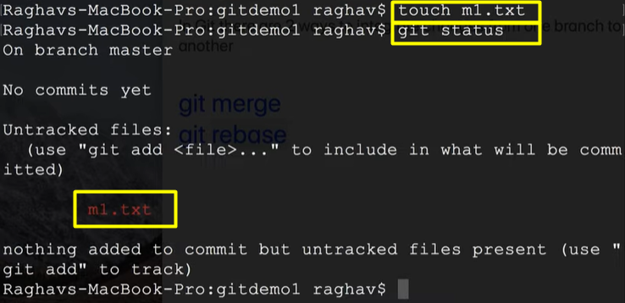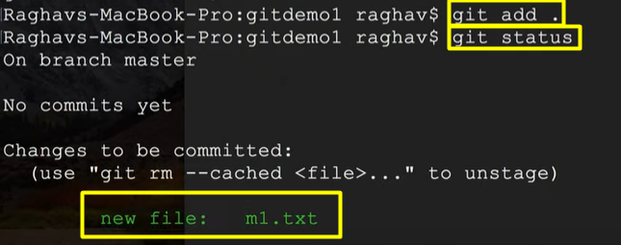

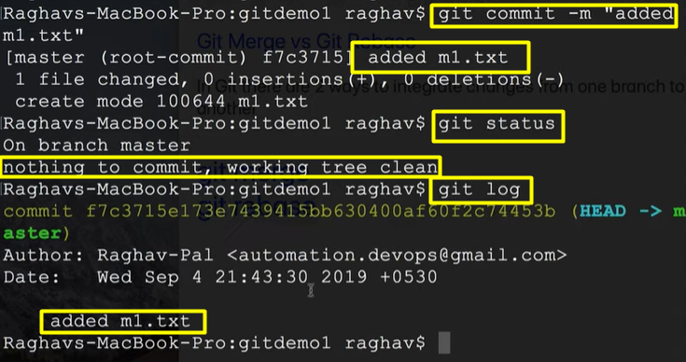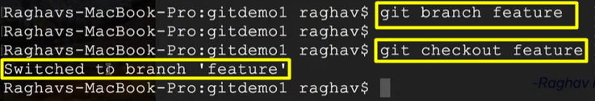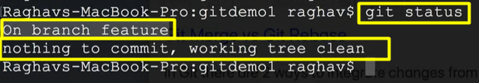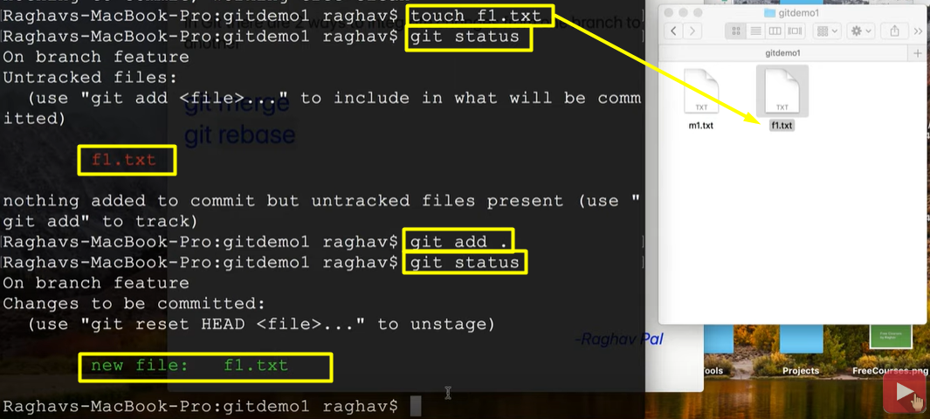

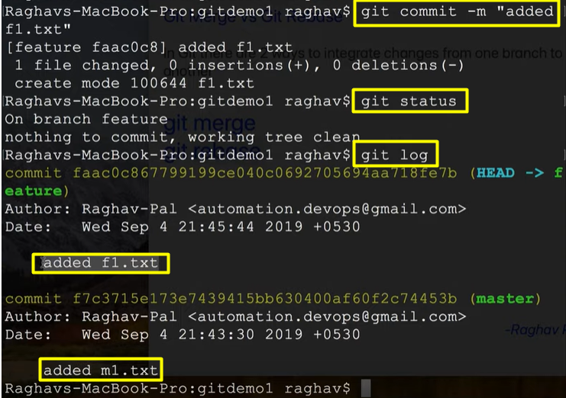

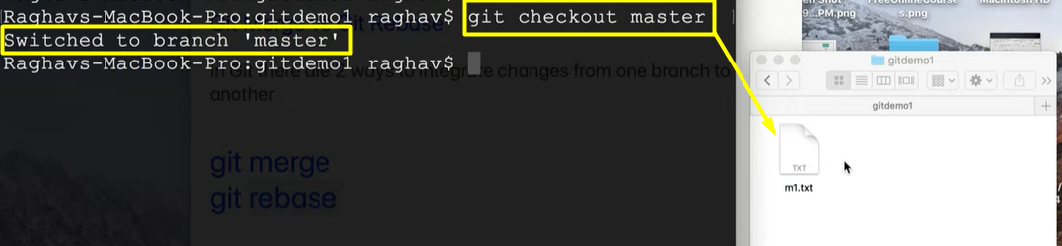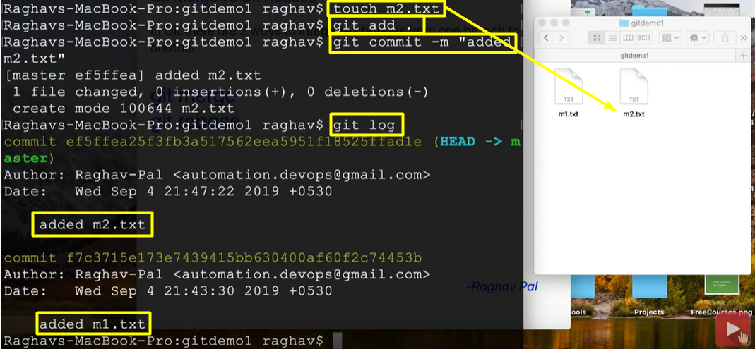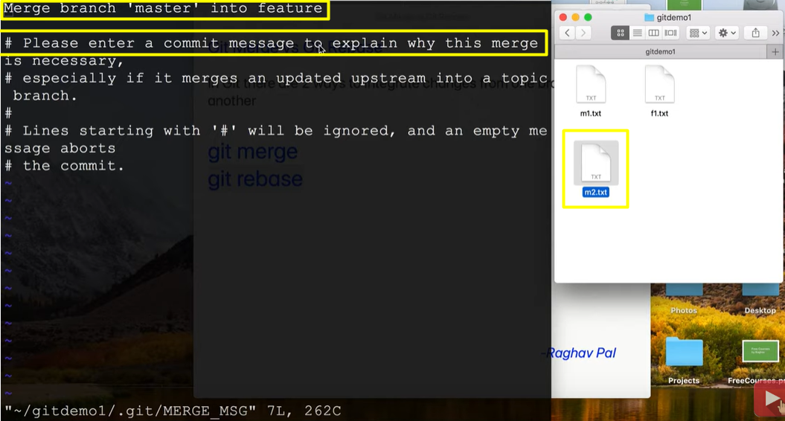

-> To enter commit msg to explain why this merge, press ‘ i ’ from keyboard then we can able to enter msg

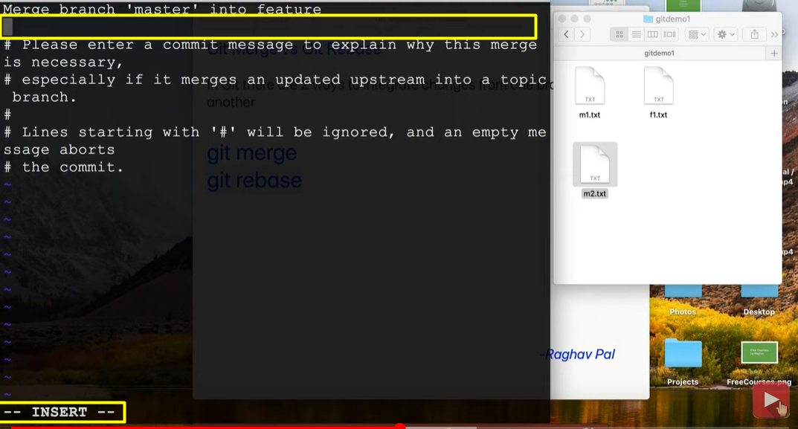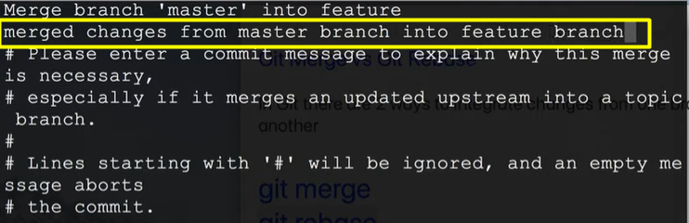

-> After adding msg press “Esc” key then “:wq!” or “:wq” then “Enter” => you will come out

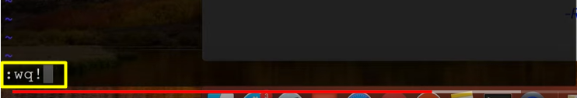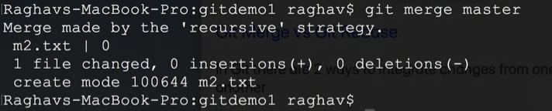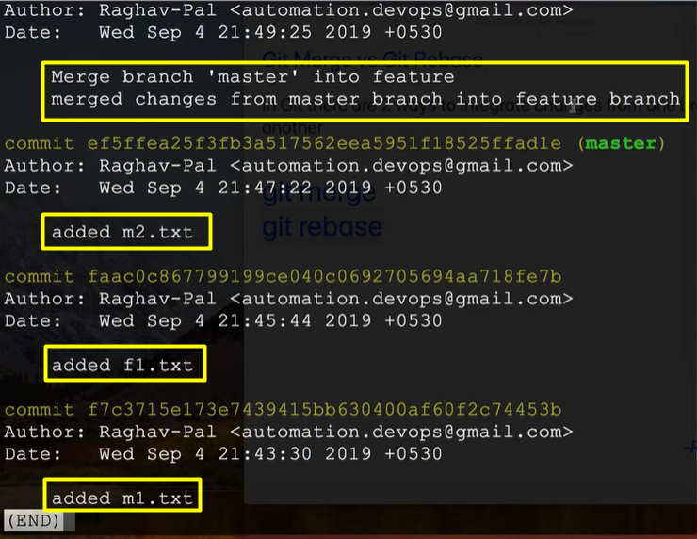

-> Press “ ctrl + z ” to come out of log

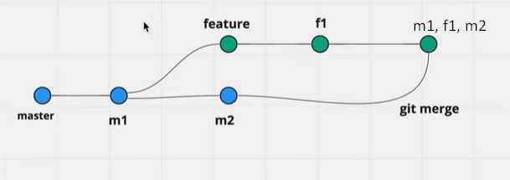

-> This is what happened in whole process of integrating changes from one branch to other using “ git merge ”

**Git Rebase:**Create a folder: gitdemo2 -> Open Git bash in the filder

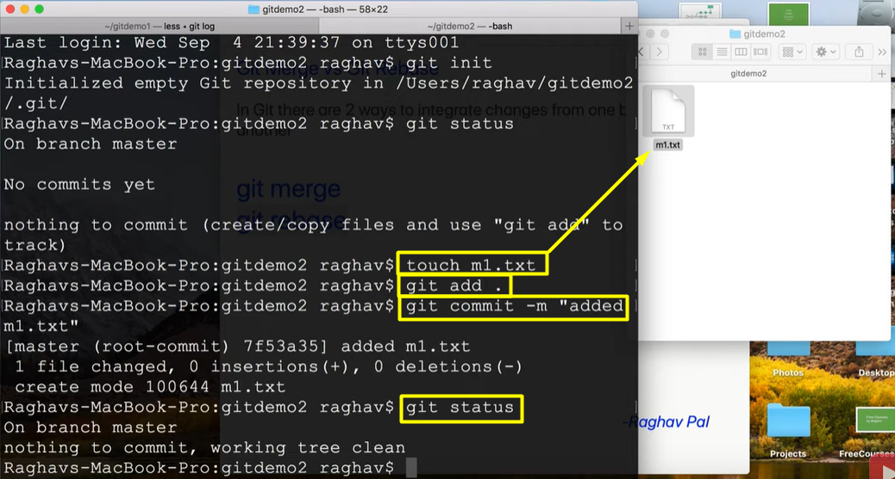 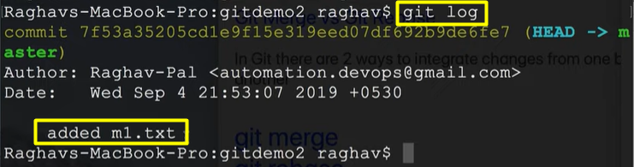 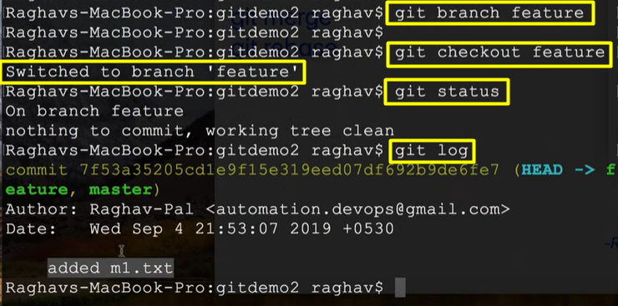 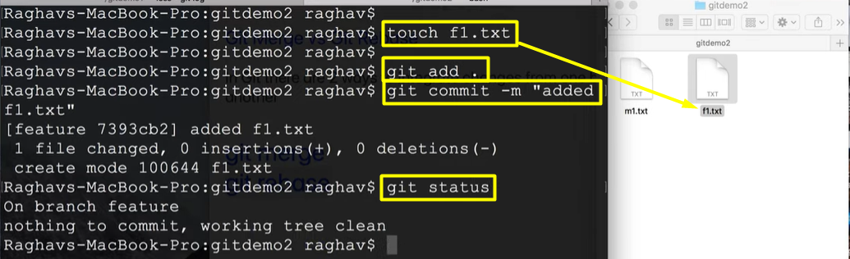

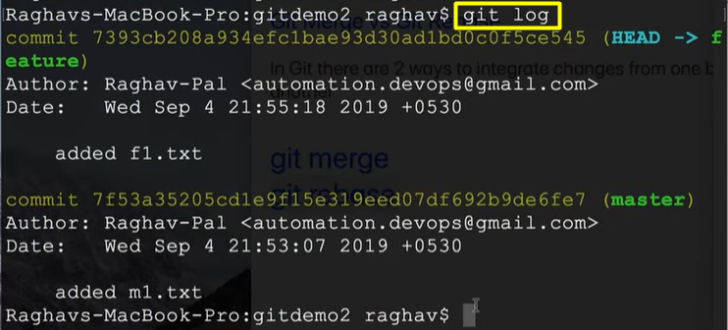 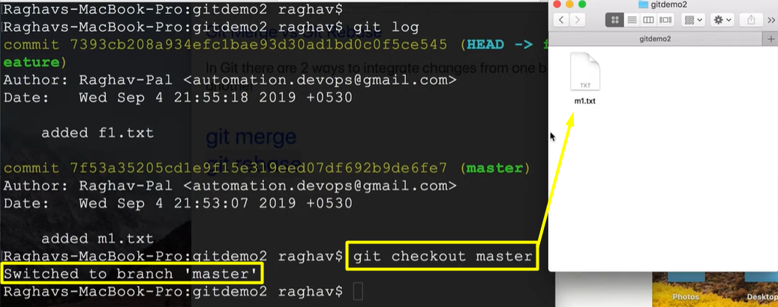 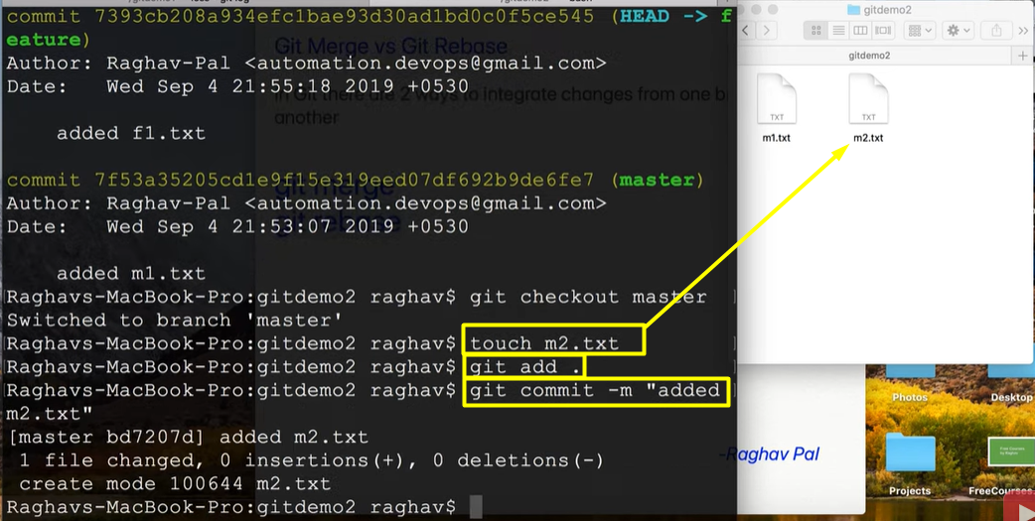

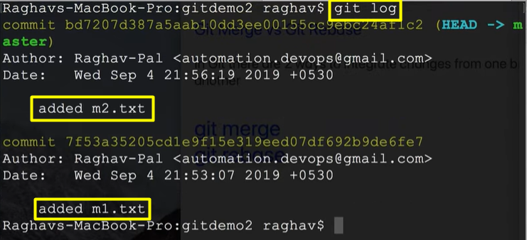 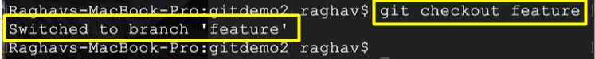 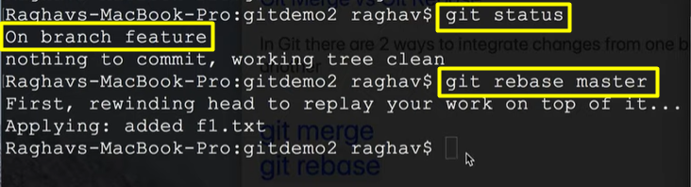 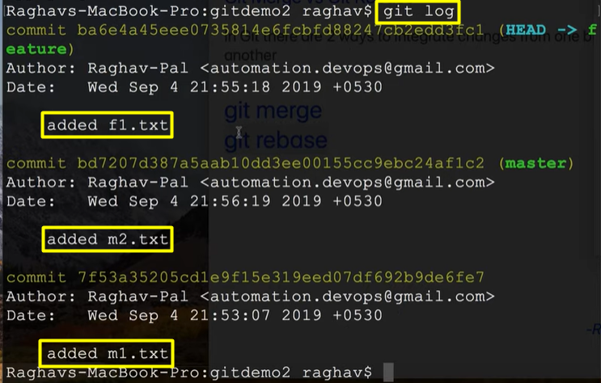

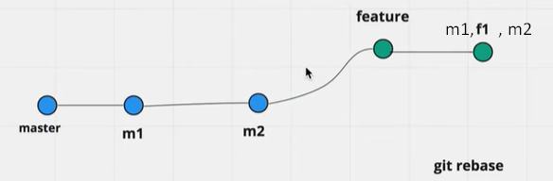

-> features branch will be added to the end of master branch by rebase

**git merge vs git rebase**

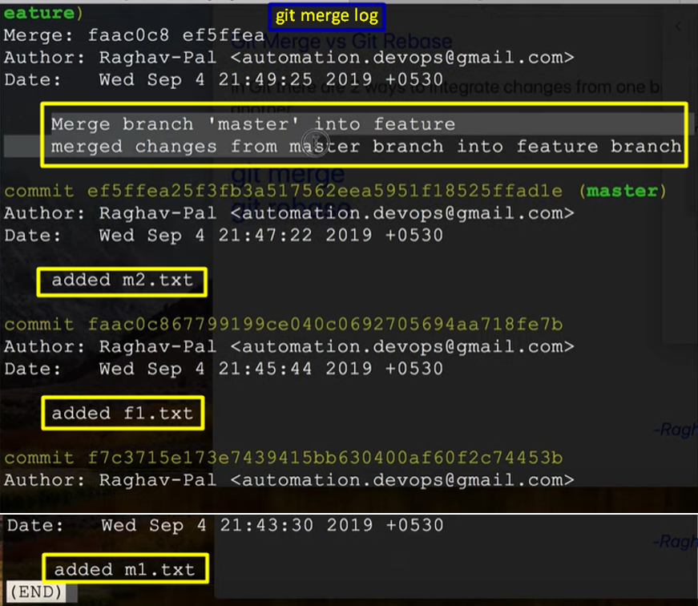 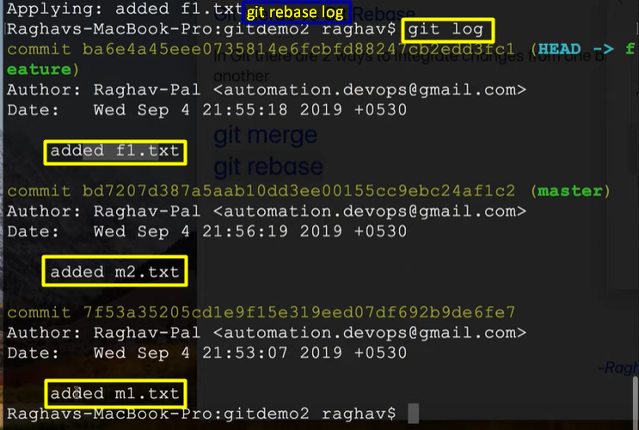

-> If we observe in git merge log, a new merge commit will be there(indicates end of master branch will be connected to the end of feature branch).

-> But if we observe the git rebase log, there is no separate merge commit, and looks very linear(indiactes end of master branch branch will be connected the to the beginning of feature branch).

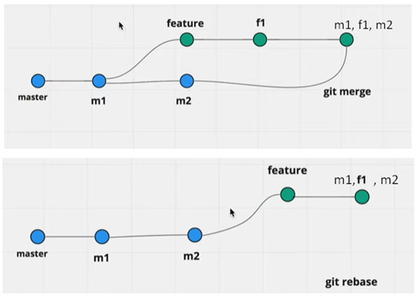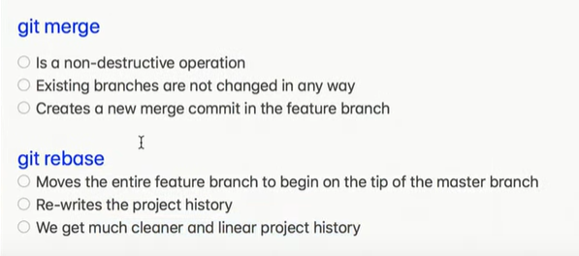

**How to Add Eclipse Project to GitHub | How to Commit, Push, Pull from Eclipse to GiHub**

1. Create GitHiub account and sign in
2. Create a repository
3. Start eclipse
4. Goto Perpective -> Git Repositories and click on Add Git Repo
5. Create a project in eclipse
6. Right click on project -> Team -> Share -> Add to git repo
7. Commit and Push the project to the repo
8. Commit and Push every change to repo